Inspiration and Reading on Screen
Rebecca McCready, Learning and Teaching Advisor
School of Medical Sciences Education Development, Faculty of Medical Sciences, Newcastle University.

Introduction
There is a lot of software available on campus, but the chances are, you haven’t come across most of it, unless specifically introduced to it. This software offers many opportunities for effective study, and this document summarises three useful but little known pieces that you may want to consider using during your degree:
- Inspiration;
- ReadWrite;
- ScreenRuler.

What is Inspiration?
Inspiration supports visual learning techniques to think, brain storm, organise, analyse and write. It can help to create mind maps (bubble diagrams), flow charts, lists, process flows, notes and schedules. It is flexible and easy to use, you can transform a diagram to a list and back again in seconds, and export the information into Word.

What is ReadWrite?
ReadWrite software supports on screen reading and writing by converting text to speech, predicting words, spell checking, providing homophone support and speech recognition. Whilst talking aloud to the computer in a cluster would be less than ideal, having it read your essay or an e-journal back to you whilst you close your eyes might be extremely helpful!

What is ScreenRuler?
ScreenRuler puts a slightly magnified bar across the screen to help with on screen reading. A range of features dims the non-magnified sections to help keep your place on screen, and can invert colours and change the mouse pointer to help with extended working with a monitor. It’s extremely helpful if you are doing a lot of intensive on screen reading and want to sit back a little whilst you read.

Why would I use this software?
Two short studies using Faculty of Medical Sciences students have shown the benefits of using ScreenRuler (Ref) and Inspiration (Ref) for academic study.

Inspiration
There are plenty of uses for Inspiration that you might want to consider, and some of these are outlined in Figure 1 and Table 1 below. However, you may find it most beneficial if you have a visual learning preference. Check out this online survey to see what learning preference you have, though don’t be restricted by this feedback when learning: http://www.vark-learn.com/english/index.asp.
Figure 2: Uses of Inspiration software as suggested by study participants.

Table 1 lists some ideas for using Inspiration.
Type of study | Suggested activities
Presentations | Planning slides, creating notes and handouts.
Debates | Rapid assimilation of information to assist with compiling the debate.
Assignments | Get an overview of the topic and structure the assignment before writing.
Group meetings | Plan when to meet, note availability and decide agendas.
Group notes | Summarise group work in neat documents for all to use.
Study timetable | Get a good overview of what you need to cover, to help plan your time and cover it all.
Base unit/SSC/ Dissertation project allocation | Assemble information to identify areas to investigate, help make informed choices, and help with preparations.
Budget planning | Gain a good idea of what you spend your money on, so you know how to save your student loan, or what to ask your parents for!
[Edit the table style, modify the table total row, change the border to single top]

ReadWrite
ReadWrite is great if you are doing lots of onscreen reading and would prefer to have it read to you instead. This may be useful if you find it easier to spot mistakes by hearing information rather than reading, if you are dyslexic or find written English difficult, or are feeling tired or hung-over.
You’ll need a set of headphones to make good use of it; you can borrow a set from the cluster advisor desk in the Fell cluster if you don’t have your own. Then, plug in, sit back and relax!

ScreenRuler
Students who used ScreenRuler in the software trial commented positively about the software:
“For reading chunks of text, it’s useful as it focuses your attention and prevents you from ‘getting lost’.”
“Simple but useful software.”
“Helpful as it magnified the text…”
“Interesting concept. Seemed like a nice idea.”
Some students didn’t like it at first, but if they changed their mind, they cited two main reasons for doing so: improved ease of reading on-screen and becoming accustomed to the new interface.
All students agreed that it would be useful for continuous on-screen reading but they concurred that if the activities were varied, including editing tables and diagrams and changing between a range of programs, then it was unlikely to be useful because of the distortion, distraction and overlap on the screen. Figure 3 shows what ScreenRuler looks like on screen.
Figure 3. A screenshot of ScreenRuler over an online IT tutorial.
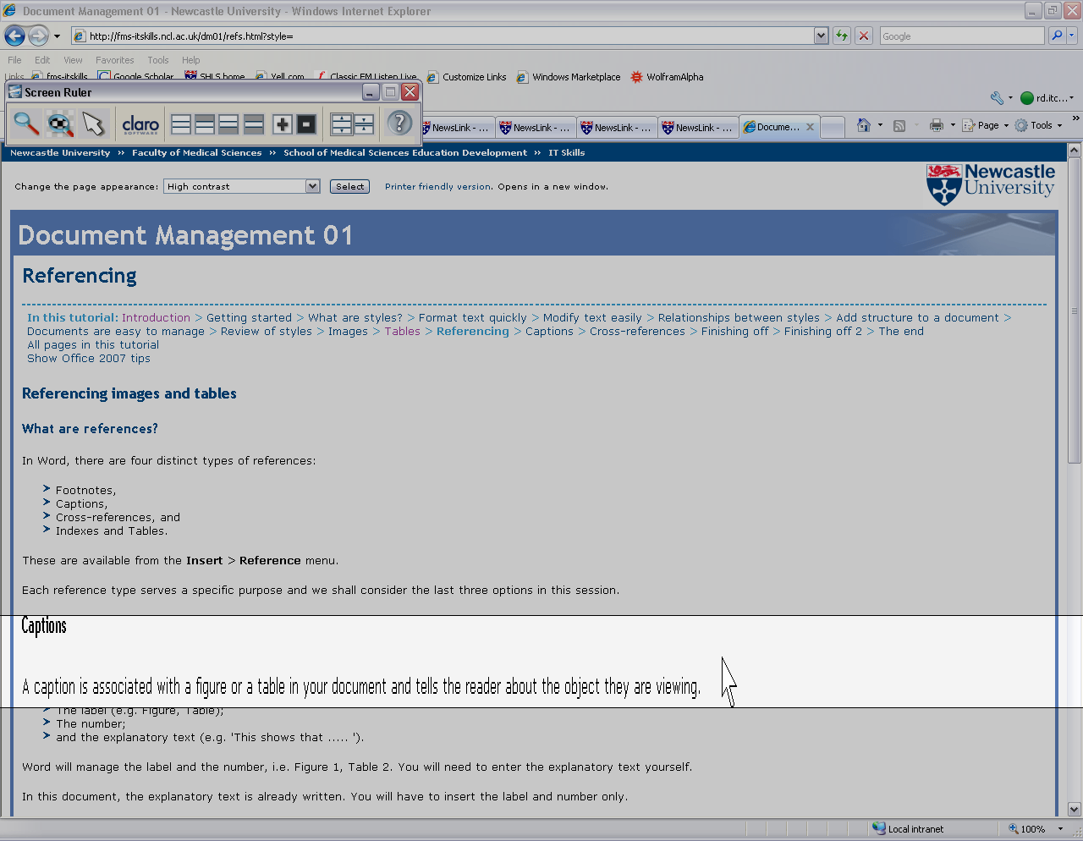
As the study results suggest, ScreenRuler works best if you are reading on screen, rather than doing multiple activities such as working with Excel, Word and IrfanView.
It’s great for:
- Reading e-journals or other online literature;
- Reading and editing coursework, especially lengthy work;
- Reading back complex emails, forms or other important documentation;
- Working with software that has small or complex buttons (for instance MS Equation Editor or Adobe Photoshop).

Finding out more
All this software is available on the campus cluster machines:
- Inspiration is available through the Start > All Programs > Graphics or EasyAccess menus.
- ReadWrite is available through the Start > All Programs > EasyAccess menu.
- ScreenRuler is only available on machines Linn01 to Linn05 in the Linn cluster, Walton Library.
All this software is available for purchase via a number of online sites, but there are no University licence agreements for home use.

Other stuff
Did you know that there are some other really useful features in Word and Office that you may find useful to manage your time, work, deadlines and priorities?
Equation Editor is a useful tool if you need to insert any equation into Word.
You can navigate your document quickly using the Document Map, available through the View ribbon > Show/Hide section. This shows all the headings within the document which, when clicking on them, takes you to that section of the document. The Ctrl G keyboard shortcut allows you to jump to different sections of the document in a variety of ways: excellent for navigating a long or complex document.
Don’t forget to follow latest academic IT developments on the FMS IT Skills Twitter site. Sign up online at https://twitter.com/.

